Using Open Policy Agent (OPA)

Using Open Policy Agent (OPA) and Gatekeeper for policy-based control in Amazon EKS
Security and governance is a critical component of configuring and managing fine-grained control for Kubernetes clusters and applications. Amazon EKS provides secure, managed Kubernetes clusters by default, but you still need to ensure that you configure and administer the applications appropriately that you run as part of the cluster.
The Open Policy Agent (OPA, pronounced “oh-pa”) is an open source, general-purpose policy engine that unifies policy enforcement across the stack. OPA provides a high-level declarative language that lets you specify policy as code and simple APIs to offload policy decision-making from your software. You can use OPA to enforce policies in microservices, Kubernetes, CI/CD pipelines, API gateways, and more. OPA uses a policy language known as Rego which is a query language which was purpose built to support structured document models such as JSON. To learn more about Rego check out this link .
OPA Gatekeeper is an open-source project that provides a first-class integration between OPA and Kubernetes. What Gatekeeper adds is an extensible parameterized policy library that includes native Kubernetes CRD's for instantiating and extending the OPA policy library. The Kubernetes API Server is configured to query OPA for admission control decisions when objects (e.g., Pods, Services, etc.) are created, updated, or deleted. The API Server sends the entire Kubernetes object in the webhook request to OPA. OPA evaluates the policies it has loaded using the admission review as input. Gatekeeper also provides audit functionality as well. The diagram below shows the flow between a user making a request to the Kube-API server and how AdmissionReview and AdmissionRequests are made through OPA Gatekeeper.
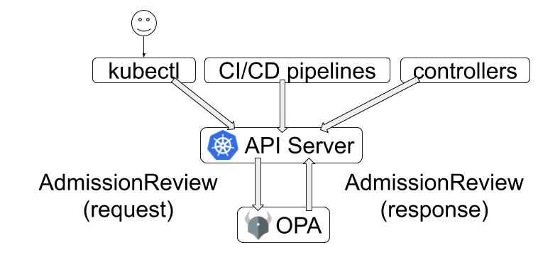
OPA decouples policy decision-making from policy enforcement. When your software needs to make policy decisions it queries OPA and supplies structured data (e.g., JSON) as input. OPA accepts arbitrary structured data as input.In the context of a development platform running on Amazon EKS, platform teams and administrators need a way of being able to set policies to adhere to governance and security requirements for all workloads and teams working on the same cluster. Examples of standard use cases for using policies via OPA Gatekeeper are listed below:
- Which users can access which resources.
- Which subnets egress traffic is allowed to.
- Which clusters a workload must be deployed to.
- Which registries binaries can be downloaded from.
- Which OS capabilities a container can execute with.
- Which times of day the system can be accessed at.
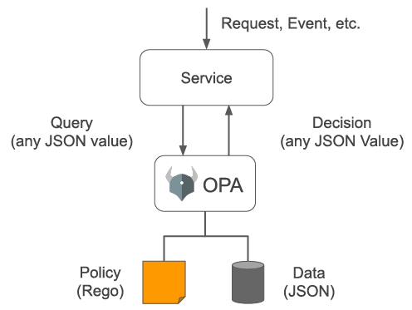
OPA generates policy decisions by evaluating the query input and against policies and data. OPA and Rego are domain-agnostic so you can describe almost any kind of invariant in your policies. Policy decisions are not limited to simple yes/no or allow/deny answers. Like query inputs, your policies can generate arbitrary structured data as output.
Key Terminology
- OPA Constraint Framework - Framework that enforces CRD-based policies and allow declaratively configured policies to be reliably shareable
- Constraint - A Constraint is a declaration that its author wants a system to meet a given set of requirements. Each Constraint is written with Rego , a declarative query language used by OPA to enumerate instances of data that violate the expected state of the system. All Constraints are evaluated as a logical AND. If one Constraint is not satisfied, then the whole request is rejected.
- Enforcement Point - Places where constraints can be enforced. Examples are Git hooks, Kubernetes admission controllers, and audit systems.
- Constraint Template - Templates that allows users to declare new constraints
- Target - Represents a coherent set of objects sharing a common identification and/or selection scheme, generic purpose, and can be analyzed in the same validation context
AWS Blogs on OPA:
- Using Open Policy Agent on Amazon EKS
- Realize Policy-as-Code with AWS Cloud Development Kit through Open Policy Agent
- Policy-based countermeasures for Kubernetes – Part 1
- Policy-based countermeasures for Kubernetes – Part 2
In this workshop, we will look at how to implement OPA on an Amazon EKS cluster as well as some sample scenarios for enforcing policies in the cluster using an OPA constraint framework.

OPA Gatekeeper setup in EKS
In this section, we will setup OPA Gatekeeper within the cluster.
- Run the following commands to deploy OPA Gatekeeper using Prebuilt docker images
kubectl apply -f https://raw.githubusercontent.com/open-policy-agent/gatekeeper/master/deploy/gatekeeper.yaml
Check Output
1
2
3
4
5
6
7
8
9
10
11
12
13
14
15
16
17
18
19
20
21
22
23
24
25
26
namespace/gatekeeper-system created
resourcequota/gatekeeper-critical-pods created
customresourcedefinition.apiextensions.k8s.io/assign.mutations.gatekeeper.sh created
customresourcedefinition.apiextensions.k8s.io/assignimage.mutations.gatekeeper.sh created
customresourcedefinition.apiextensions.k8s.io/assignmetadata.mutations.gatekeeper.sh created
customresourcedefinition.apiextensions.k8s.io/configs.config.gatekeeper.sh created
customresourcedefinition.apiextensions.k8s.io/constraintpodstatuses.status.gatekeeper.sh created
customresourcedefinition.apiextensions.k8s.io/constrainttemplatepodstatuses.status.gatekeeper.sh created
customresourcedefinition.apiextensions.k8s.io/constrainttemplates.templates.gatekeeper.sh created
customresourcedefinition.apiextensions.k8s.io/expansiontemplate.expansion.gatekeeper.sh created
customresourcedefinition.apiextensions.k8s.io/expansiontemplatepodstatuses.status.gatekeeper.sh created
customresourcedefinition.apiextensions.k8s.io/modifyset.mutations.gatekeeper.sh created
customresourcedefinition.apiextensions.k8s.io/mutatorpodstatuses.status.gatekeeper.sh created
customresourcedefinition.apiextensions.k8s.io/providers.externaldata.gatekeeper.sh created
serviceaccount/gatekeeper-admin created
role.rbac.authorization.k8s.io/gatekeeper-manager-role created
clusterrole.rbac.authorization.k8s.io/gatekeeper-manager-role created
rolebinding.rbac.authorization.k8s.io/gatekeeper-manager-rolebinding created
clusterrolebinding.rbac.authorization.k8s.io/gatekeeper-manager-rolebinding created
secret/gatekeeper-webhook-server-cert created
service/gatekeeper-webhook-service created
deployment.apps/gatekeeper-audit created
deployment.apps/gatekeeper-controller-manager created
poddisruptionbudget.policy/gatekeeper-controller-manager created
mutatingwebhookconfiguration.admissionregistration.k8s.io/gatekeeper-mutating-webhook-configuration created
validatingwebhookconfiguration.admissionregistration.k8s.io/gatekeeper-validating-webhook-configuration created

- To validate that OPA Gatekeeper is running within your cluster run the following command:
kubectl get pods -n gatekeeper-system
The output will look like below.
1
2
3
4
5
NAME READY STATUS RESTARTS AGE
gatekeeper-audit-6584df88df-nsf28 1/1 Running 1 (37s ago) 41s
gatekeeper-controller-manager-5ff69b954d-nvzsb 1/1 Running 0 41s
gatekeeper-controller-manager-5ff69b954d-pmm7v 1/1 Running 0 41s
gatekeeper-controller-manager-5ff69b954d-t59kk 1/1 Running 0 41s
If you notice the gatekeeper-audit-6584df88df-nsf28 pod is created when we deploy the OpaGatekeeperAddOn. The audit functionality enables periodic evaluations of replicated resources against the Constraints enforced in the cluster to detect pre-existing misconfigurations. Gatekeeper stores audit results as violations listed in the status field of the relevant Constraint. The gatekeeper-controller-manager is simply there to manage the OpaGatekeeperAddOn.
- Once OPA Gatekeeper pods are in 'Running' state, monitor Audit controller and Controller manager component logs for webhook requests that are being issued by the Kubernetes API server.
Run the following command in separate terminal window to monitor Audit controller logs
kubectl logs -l control-plane=audit-controller -n gatekeeper-system -f
Check Output
1
2
3
4
5
6
7
8
9
10
{"level":"info","ts":1691054570.044209,"logger":"controller","msg":"resource count","metaKind":"upgrade","count":0}
{"level":"info","ts":1691054570.0442343,"logger":"controller","msg":"resource","metaKind":"upgrade","kind":"AssignMetadata","group":"mutations.gatekeeper.sh","version":"v1alpha1"}
{"level":"info","ts":1691054570.0488415,"logger":"controller","msg":"resource count","metaKind":"upgrade","count":0}
{"level":"info","ts":1691054570.0620747,"logger":"controller","msg":"resource","metaKind":"upgrade","kind":"Provider","group":"externaldata.gatekeeper.sh","version":"v1alpha1"}
{"level":"info","ts":1691054570.065626,"logger":"KubeAPIWarningLogger","msg":"externaldata.gatekeeper.sh/v1alpha1 is deprecated. Use externaldata.gatekeeper.sh/v1beta1 instead."}
{"level":"info","ts":1691054570.065955,"logger":"controller","msg":"resource count","metaKind":"upgrade","count":0}
{"level":"info","ts":1691054572.327456,"logger":"readiness-tracker","msg":"readiness satisfied, no further collection"}
{"level":"info","ts":1691054629.8365571,"logger":"controller","msg":"auditing constraints and violations","process":"audit","audit_id":"2023-08-03T09:23:49Z","event_type":"audit_started"}
{"level":"info","ts":1691054629.8529487,"logger":"controller","msg":"no constraint is found with apiversion","process":"audit","audit_id":"2023-08-03T09:23:49Z","constraint apiversion":"constraints.gatekeeper.sh/v1beta1"}
{"level":"info","ts":1691054629.8529873,"logger":"controller","msg":"auditing is complete","process":"audit","audit_id":"2023-08-03T09:23:49Z","event_type":"audit_finished"}

Run the following command in separate terminal window to monitor Controller manager logs
kubectl logs -l control-plane=controller-manager -n gatekeeper-system -f
Check Output
1
2
3
4
5
6
7
8
9
10
11
12
13
14
15
16
17
18
19
20
21
22
23
24
25
26
27
28
29
30
{"level":"info","ts":1691054569.154963,"logger":"controller","msg":"resource count","metaKind":"upgrade","count":0}
{"level":"info","ts":1691054569.1549916,"logger":"controller","msg":"resource","metaKind":"upgrade","kind":"ModifySet","group":"mutations.gatekeeper.sh","version":"v1alpha1"}
{"level":"info","ts":1691054569.1592152,"msg":"Starting workers","controller":"externaldata-controller","worker count":1}
{"level":"info","ts":1691054569.160231,"logger":"controller","msg":"resource count","metaKind":"upgrade","count":0}
{"level":"info","ts":1691054569.1602528,"logger":"controller","msg":"resource","metaKind":"upgrade","kind":"Assign","group":"mutations.gatekeeper.sh","version":"v1alpha1"}
{"level":"info","ts":1691054569.1637428,"logger":"controller","msg":"resource count","metaKind":"upgrade","count":0}
{"level":"info","ts":1691054569.213409,"logger":"controller","msg":"resource","metaKind":"upgrade","kind":"Provider","group":"externaldata.gatekeeper.sh","version":"v1alpha1"}
{"level":"info","ts":1691054569.216204,"logger":"KubeAPIWarningLogger","msg":"externaldata.gatekeeper.sh/v1alpha1 is deprecated. Use externaldata.gatekeeper.sh/v1beta1 instead."}
{"level":"info","ts":1691054569.216296,"logger":"controller","msg":"resource count","metaKind":"upgrade","count":0}
{"level":"info","ts":1691054570.6133084,"logger":"readiness-tracker","msg":"readiness satisfied, no further collection"}
{"level":"info","ts":1691054570.425286,"logger":"controller","msg":"resource","metaKind":"upgrade","kind":"ModifySet","group":"mutations.gatekeeper.sh","version":"v1alpha1"}
{"level":"info","ts":1691054570.4296567,"logger":"controller","msg":"resource count","metaKind":"upgrade","count":0}
{"level":"info","ts":1691054570.4389153,"msg":"Starting workers","controller":"constraint-controller","worker count":1}
{"level":"info","ts":1691054570.438918,"msg":"Starting workers","controller":"externaldata-controller","worker count":1}
{"level":"info","ts":1691054570.4442906,"logger":"controller","msg":"resource","metaKind":"upgrade","kind":"Provider","group":"externaldata.gatekeeper.sh","version":"v1alpha1"}
{"level":"info","ts":1691054570.4474301,"logger":"KubeAPIWarningLogger","msg":"externaldata.gatekeeper.sh/v1alpha1 is deprecated. Use externaldata.gatekeeper.sh/v1beta1 instead."}
{"level":"info","ts":1691054570.447586,"logger":"controller","msg":"resource count","metaKind":"upgrade","count":0}
{"level":"info","ts":1691054570.4498425,"msg":"Starting workers","controller":"modifyset-controller","worker count":1}
{"level":"info","ts":1691054570.4542532,"msg":"Starting workers","controller":"assignmetadata-controller","worker count":1}
{"level":"info","ts":1691054571.0831826,"logger":"readiness-tracker","msg":"readiness satisfied, no further collection"}
{"level":"info","ts":1691054569.9443588,"logger":"controller","msg":"resource","metaKind":"upgrade","kind":"AssignImage","group":"mutations.gatekeeper.sh","version":"v1alpha1"}
{"level":"info","ts":1691054569.947655,"logger":"controller","msg":"resource count","metaKind":"upgrade","count":0}
{"level":"info","ts":1691054569.9517624,"msg":"Starting workers","controller":"constraint-controller","worker count":1}
{"level":"info","ts":1691054569.9617753,"msg":"Starting workers","controller":"assignmetadata-controller","worker count":1}
{"level":"info","ts":1691054569.9618478,"msg":"Starting workers","controller":"externaldata-controller","worker count":1}
{"level":"info","ts":1691054569.9641025,"msg":"Starting workers","controller":"modifyset-controller","worker count":1}
{"level":"info","ts":1691054569.9651625,"logger":"controller","msg":"resource","metaKind":"upgrade","kind":"Provider","group":"externaldata.gatekeeper.sh","version":"v1alpha1"}
{"level":"info","ts":1691054569.9685936,"logger":"KubeAPIWarningLogger","msg":"externaldata.gatekeeper.sh/v1alpha1 is deprecated. Use externaldata.gatekeeper.sh/v1beta1 instead."}
{"level":"info","ts":1691054569.9686935,"logger":"controller","msg":"resource count","metaKind":"upgrade","count":0}
{"level":"info","ts":1691054570.4463212,"logger":"readiness-tracker","msg":"readiness satisfied, no further collection"}

You can follow the OPA logs to see the webhook requests being issued by the Kubernetes API server.
This completes the OPA Gatekeeper setup on Amazon EKS cluster. In order to define and enforce the policy, OPA Gatekeeper uses a framework OPA Constraint Framework

Use case #1: Restrict privileged containers in the cluster
In this section, we will define a new constraint template and constraint that will force the cluster to use unprivileged containers.

Build Constraint Templates

ConstraintTemplate describes the Rego that enforces the constraint and the schema of the constraint. The schema constraint allows the author of the constraint (cluster admin) to define the constraint behavior.
In this scenario, the cluster administrator will force the cluster to use unprivileged containers. The OPA Gatekeeper will look for the securitycontext field and determine whether 'privileged=true' is present. If this is the case, the request will fail.
cd ~/environment
cat > constrainttemplate-1.yaml <<EOF
apiVersion: templates.gatekeeper.sh/v1beta1
kind: ConstraintTemplate
metadata:
name: k8spspprivilegedcontainer
spec:
crd:
spec:
names:
kind: K8sPSPPrivilegedContainer
targets:
- target: admission.k8s.gatekeeper.sh
rego: |
package k8spspprivileged

violation[{"msg": msg, "details": {}}] {
c := input_containers[_]
c.securityContext.privileged
msg := sprintf("Privileged container is not allowed: %v, securityContext: %v", [c.name, c.securityContext])
}

input_containers[c] {
c := input.review.object.spec.containers[_]
}

input_containers[c] {
c := input.review.object.spec.initContainers[_]
}
EOF
Create the ConstraintTemplate using the following command
kubectl create -f constrainttemplate-1.yaml
Check Output
1
constrainttemplate.templates.gatekeeper.sh/k8spspprivilegedcontainer created
Ensure that the CRD constrainttemplate is created.
kubectl get constrainttemplate
Check Output
1
2
NAME AGE
k8spspprivilegedcontainer 61s

Build Constraint

To enforce the policy, we will use the constraint below, which will ensure that all newly created pods are not privileged.
cd ~/environment
cat > constraint-1.yaml <<EOF
apiVersion: constraints.gatekeeper.sh/v1beta1
kind: K8sPSPPrivilegedContainer
metadata:
name: psp-privileged-container
spec:
match:
kinds:
- apiGroups: [""]
kinds: ["Pod"]
EOF
Create the Constraint using the following command
kubectl create -f constraint-1.yaml
Check Output
1
k8spspprivilegedcontainer.constraints.gatekeeper.sh/psp-privileged-container created
Ensure that the CRD for constraint is created.
kubectl get constraint
Check Output
1
2
NAME ENFORCEMENT-ACTION TOTAL-VIOLATIONS
psp-privileged-container

Test the policy

In this section, we will test if the use of unprivileged containers is enforced in the cluster or not,
Let us deploy a privileged nginx pod:

cd ~/environment
cat > example-1.yaml <<EOF
apiVersion: v1
kind: Pod
metadata:
name: bad-nginx
labels:
app: bad-nginx
spec:
containers:
- name: nginx
image: nginx
securityContext:
privileged: true
EOF
kubectl create -f example-1.yaml
You should now see an error message similar to below:
Check Output
Error from server (Forbidden): error when creating "example-1.yaml": admission webhook "validation.gatekeeper.sh" denied the request: [psp-privileged-container] Privileged container is not allowed: nginx, securityContext: {"privileged": true}
Additionally, check the Controller manager logs to see the webhook requests sent by the Kubernetes API server for validation and mutation, as well as the Audit logs to check for policy compliance on objects that already exist in the cluster.
Controller Manager Logs
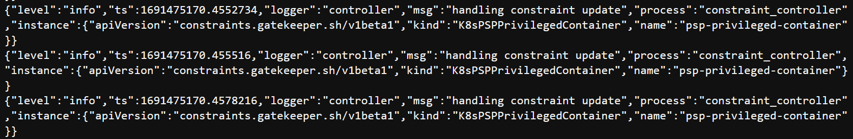
Audit Controller Logs
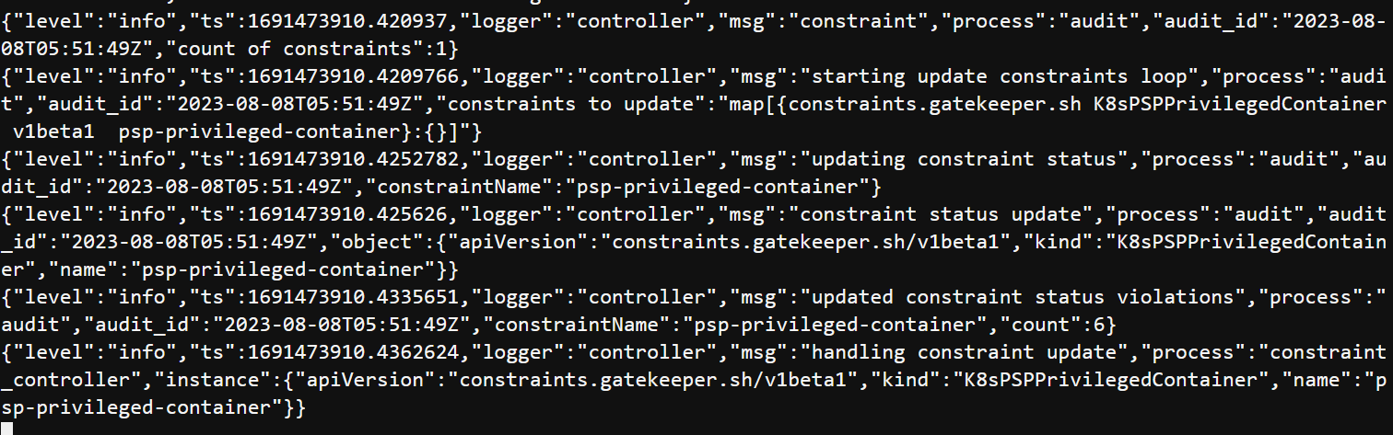
The request was denied by the Kubernetes API because it did not meet the requirement of unprivileged containers imposed by the OPA Gatekeeper constraint.

Use case #2: Whitelist only known registry
This section will define a new constraint template and constraint that will verify that every pod's image comes from a known registry on a whitelist.

Build Constraint Templates

In the example below, the cluster administrator will mandate that only known image repositories be used in the cluster.
cd ~/environment
cat > constrainttemplate-2.yaml <<EOF
apiVersion: templates.gatekeeper.sh/v1beta1
kind: ConstraintTemplate
metadata:
name: k8swhitelistedimages
spec:
crd:
spec:
names:
kind: k8sWhitelistedImages
validation:
# Schema for the parameters field
openAPIV3Schema:
properties:
images:
type: array
items: string
targets:
- target: admission.k8s.gatekeeper.sh
rego: |
package k8swhitelistedimages
whitelisted_images = {images |
images = input.parameters.images[_]
}

images_whitelisted(str, patterns) {
image_matches(str, patterns[_])
}

image_matches(str, pattern) {
contains(str, pattern)
}
violation[{"msg": msg}] {
input.review.object
image := input.review.object.spec.containers[_].image
name := input.review.object.metadata.name
not images_whitelisted(image, whitelisted_images)
msg := sprintf("pod %q has invalid image %q. Please, contact your DevOps. Follow the whitelisted images %v", [name, image, whitelisted_images])
}
EOF

Create the ConstraintTemplate using the following command
kubectl create -f constrainttemplate-2.yaml
Check Output
1
constrainttemplate.templates.gatekeeper.sh/k8swhitelistedimages created
Ensure that the CRD for constrainttemplate is created.
kubectl get constrainttemplate
Check Output
1
2
NAME AGE
k8swhitelistedimages 4m15s

Build Constraint

To enforce the policy, we will use the constraint below, which will ensure that all newly created pods image comes from a known registry on a whitelist
cd ~/environment
cat > constraint-2.yaml <<EOF
apiVersion: constraints.gatekeeper.sh/v1beta1
kind: k8sWhitelistedImages
metadata:
name: k8senforcewhitelistedimages
spec:
match:
kinds:
- apiGroups: [""]
kinds: ["Pod"]
parameters:
images:
# AWS Internal ECR registries
- 999999999999.dkr.ecr.us-east-1.amazonaws.com/
# AWS Public Registries
- 888888888888.dkr.ecr.us-west-2.amazonaws.com/
- 888888888888.dkr.ecr.us-east-1.amazonaws.com/
# Images used by the infrastructure services inside the kubernetes cluster
- amazon/aws-node-termination-handler
- amazon/aws-alb-ingress-controller
- amazon/aws-efs-csi-driver
- amazon/cloudwatch-agent
- docker.io/amazon/aws-alb-ingress-controller
- nvidia/k8s-device-plugin
- k8s.gcr.io/autoscaling/cluster-autoscaler
- k8s.gcr.io/metrics-server-amd64
- quay.io/coreos/kube-state-metrics
- quay.io/kubernetes-ingress-controller/nginx-ingress-controller
- kubernetesui/dashboard
- kubernetesui/metrics-scraper
- jtblin/kube2iam
- grafana/grafana
- prom/alertmanager
- prom/prometheus
- openpolicyagent/gatekeeper
# Images for support
- amazon/aws-cli
- radial/busyboxplus
- docker.io/radial/busyboxplus
- busybox
EOF
Create the Constraint using the following command
kubectl create -f constraint-2.yaml
Check Output
1
k8swhitelistedimages.constraints.gatekeeper.sh/k8senforcewhitelistedimages created
Ensure that the CRD for constraint is created.
kubectl get constraint
Check Output
1
2
NAME ENFORCEMENT-ACTION TOTAL-VIOLATIONS
k8swhitelistedimages.constraints.gatekeeper.sh/k8senforcewhitelistedimages

Test the policy

Let’s deploy a nginx pod from unknown registry.

cd ~/environment
cat > example-2.yaml <<EOF
apiVersion: v1
kind: Pod
metadata:
name: bad-nginx
labels:
app: bad-nginx
spec:
containers:
- name: nginx
image: nginx
EOF
kubectl create -f example-2.yaml
You should now see an error message similar to below:
Check Output
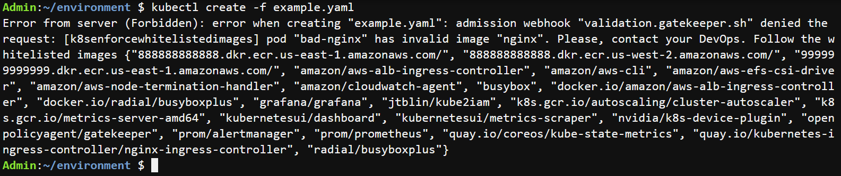
Error from server (Forbidden): error when creating "example-2.yaml": admission webhook "validation.gatekeeper.sh" denied the request: [k8senforcewhitelistedimages] pod "bad-nginx" has invalid image "nginx". Please, contact your DevOps. Follow the whitelisted images {"888888888888.dkr.ecr.us-east-1.amazonaws.com/", "888888888888.dkr.ecr.us-west-2.amazonaws.com/", "999999999999.dkr.ecr.us-east-1.amazonaws.com/", "amazon/aws-alb-ingress-controller", "amazon/aws-cli", "amazon/aws-efs-csi-driver", "amazon/aws-node-termination-handler", "amazon/cloudwatch-agent", "busybox", "docker.io/amazon/aws-alb-ingress-controller", "docker.io/radial/busyboxplus", "grafana/grafana", "jtblin/kube2iam", "k8s.gcr.io/autoscaling/cluster-autoscaler", "k8s.gcr.io/metrics-server-amd64", "kubernetesui/dashboard", "kubernetesui/metrics-scraper", "nvidia/k8s-device-plugin", "openpolicyagent/gatekeeper", "prom/alertmanager", "prom/prometheus", "quay.io/coreos/kube-state-metrics", "quay.io/kubernetes-ingress-controller/nginx-ingress-controller", "radial/busyboxplus"}
Additionally, check the Controller manager logs to see the webhook requests sent by the Kubernetes API server for validation and mutation, as well as the Audit logs to check for policy compliance on objects that already exist in the cluster.
Check Output
Controller Manager Logs
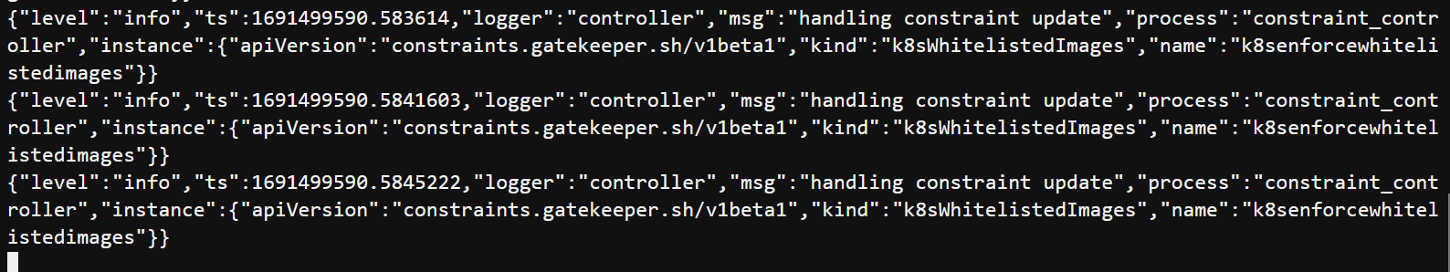
Audit Controller Logs
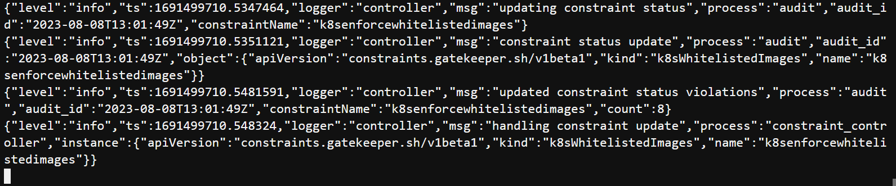
The request was denied by Kubernetes API, because it didn’t meet the requirement of known registries on whitelist imposed by OPA Gatekeeper constraint.

Use case #3: Enforce labels for objects
In this section, we will define a new constraint template as well as a constraint that enforces the inclusion of labels for namespaces and pods.

Build Constraint Templates

The template below defines a general constraint that checks for the presence of labels. Once created, the template can be used to create constraints that require the definition of a specific label or set of labels on an object.
cd ~/environment
cat > constrainttemplate-3.yaml <<EOF
apiVersion: templates.gatekeeper.sh/v1
kind: ConstraintTemplate
metadata:
name: k8srequiredlabels
annotations:
metadata.gatekeeper.sh/title: "Required Labels"
metadata.gatekeeper.sh/version: 1.0.0
description: >-
Requires resources to contain specified labels, with values matching
provided regular expressions.
spec:
crd:
spec:
names:
kind: K8sRequiredLabels
validation:
openAPIV3Schema:
type: object
properties:
message:
type: string
labels:
type: array
description: >-
A list of labels and values the object must specify.
items:
type: object
properties:
key:
type: string
description: >-
The required label.
allowedRegex:
type: string
description: >-
If specified, a regular expression the annotation's value
must match. The value must contain at least one match for
the regular expression.
targets:
- target: admission.k8s.gatekeeper.sh
rego: |
package k8srequiredlabels

get_message(parameters, _default) = msg {
not parameters.message
msg := _default
}

get_message(parameters, _default) = msg {
msg := parameters.message
}

violation[{"msg": msg, "details": {"missing_labels": missing}}] {
provided := {label | input.review.object.metadata.labels[label]}
required := {label | label := input.parameters.labels[_].key}
missing := required - provided
count(missing) > 0
def_msg := sprintf("you must provide labels: %v", [missing])
msg := get_message(input.parameters, def_msg)
}

violation[{"msg": msg}] {
value := input.review.object.metadata.labels[key]
expected := input.parameters.labels[_]
expected.key == key
# do not match if allowedRegex is not defined, or is an empty string
expected.allowedRegex != ""
not re_match(expected.allowedRegex, value)
def_msg := sprintf("Label <%v: %v> does not satisfy allowed regex: %v", [key, value, expected.allowedRegex])
msg := get_message(input.parameters, def_msg)
}

EOF

Create the ConstraintTemplate using the following command
kubectl create -f constrainttemplate-3.yaml
Check Output
1
constrainttemplate.templates.gatekeeper.sh/k8srequiredlabels created
Ensure that the CRD constrainttemplate is created.
kubectl get constrainttemplate
Check Output
1
2
NAME AGE
k8srequiredlabels 2m18s

Build Constraint

Below example contraint defines that any namespace objects that are created must have a value set for the owner label.
cd ~/environment
cat > constraint-3.yaml <<EOF
apiVersion: constraints.gatekeeper.sh/v1beta1
kind: K8sRequiredLabels
metadata:
name: all-ns-must-have-owner-label
spec:
match:
kinds:
- apiGroups: [""]
kinds: ["Namespace"]
parameters:
message: "All namespaces must have an owner label"
labels:
- key: owner
EOF
Create the Constraint using the following command
kubectl create -f constraint-3.yaml
Check Output
1
k8srequiredlabels.constraints.gatekeeper.sh/all-ns-must-have-owner-label created
Ensure that the CRD for constraint is created.
kubectl get constraint
Check Output
1
2
NAME ENFORCEMENT-ACTION TOTAL-VIOLATIONS
k8srequiredlabels.constraints.gatekeeper.sh/all-ns-must-have-owner-label

Test the policy

Let us create namespace without owner label.

cd ~/environment
cat > example-3.yaml <<EOF
apiVersion: v1
kind: Namespace
metadata:
name: test-opa
spec: {}
EOF
kubectl create -f example-3.yaml
You should now see an error message similar to below:
Check Output
Error from server (Forbidden): error when creating "example-3.yaml": admission webhook "validation.gatekeeper.sh" denied the request: [all-ns-must-have-owner-label] All namespaces must have an owner label
Additionally, check the Controller manager logs to see the webhook requests sent by the Kubernetes API server for validation and mutation, as well as the Audit logs to check for policy compliance on objects that already exist in the cluster.
Check Output
Controller Manager Logs
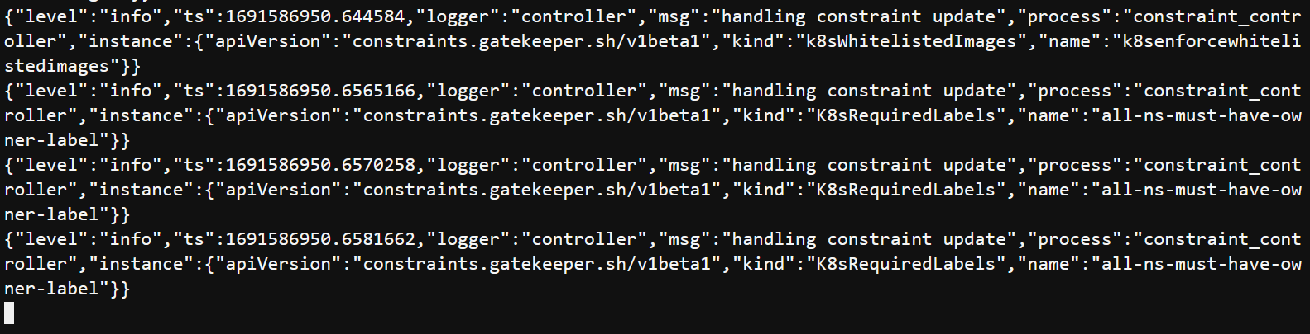
Audit Controller Logs
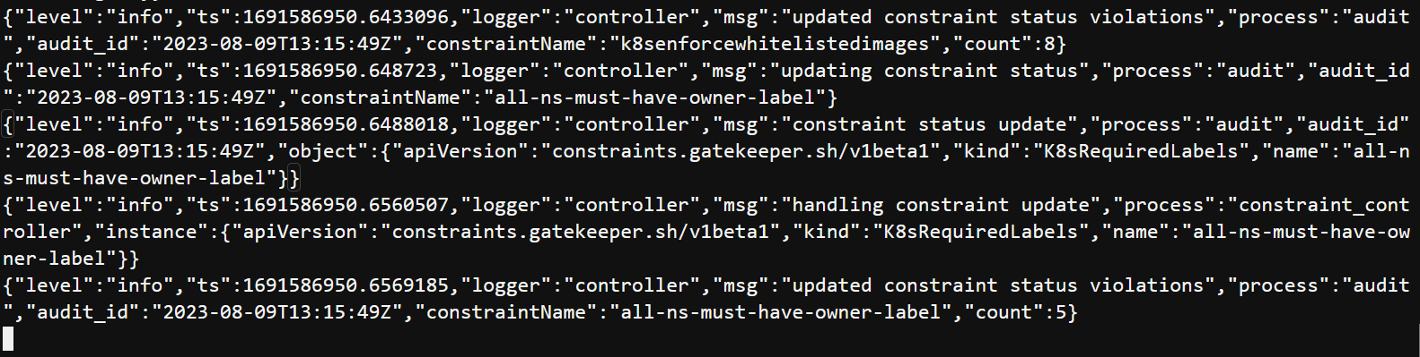
The request was denied by the Kubernetes API because it did not comply with the constraint imposed by OPA Gatekeeper that all namespace objects created must have a value set for the owner label.
Summary
Congratulations !!! We learnt how to leverage OPA Gatekeeper to implement fine-grained policies in Kubernetes clusters, enhancing overall security while also simplifying compliance and audit requirements.

Clean up
Run the following command to clean up the resources.

kubectl delete -f constrainttemplate-1.yaml
kubectl delete -f constrainttemplate-2.yaml
kubectl delete -f constrainttemplate-3.yaml

kubectl delete -f constraint-1.yaml
kubectl delete -f constraint-2.yaml
kubectl delete -f constraint-3.yaml

kubectl delete -f example-1.yaml
kubectl delete -f example-2.yaml
kubectl delete -f example-3.yaml

kubectl delete -f https://raw.githubusercontent.com/open-policy-agent/gatekeeper/master/deploy/gatekeeper.yaml

